ViSENet: Village Social Enterprise learning material, guidance and networking

ABOUT THE PROJECT↓ PARTNERS↓ RESULTS↓ CONTACT↓

ABOUT THE PROJECT
Context
As many countries’ rural areas are facing the same contemporary societal challenges, such as a tightening economy and diminishing local services, there is a need to find new tools for rural communities to cope with the future. One possible solution is the development of locally based social enterprise (SE). Social entrepreneurship can be defined as entrepreneurship that has a strong social goal where profits are reinvested back into the local community. The concept is, however, relatively novel in rural development across much of Europe. There is much local potential, embedded knowledge and skill in rural communities to improve local service provision and employment, but the people usually do not recognize this or know how to make full use of it. This is why there is a need to raise the capacity of local people to better address the community potential and needs by increasing their knowledge and skills of community activation, partnerships and networking, business thinking and recognizing the social impacts of social entrepreneurship in local communities.
Aim
The project aims to enhance the ideas and methods to promote and support social entrepreneurship in rural areas by:
- creating an open access digital learning material and opportunities for rural communities and people to foster the knowledge and awareness of the social enterprises
- supporting online learning experience of the development of social enterprises in rural environments with evaluated and piloted methods addressing local needs
- enhancing the rural communities to better interact and exchange experiences and good practices with other communities regionally , nationally and internationally by a digital networking platform as well as by establishing an international network of rural social enterprises to exchange experiences, good practices and disseminate learning material created.
Target group
The target groups of the project are individuals who are interested in developing and sustaining their rural communities, who are willing to consider socially enterprising solutions to assist their rural areas or individuals who already have an idea for social enterprise in rural areas, as well as individuals already engaged in social enterprise activity but wish to gain new skills, knowledge and expertise to assist them in their venture. Nearly 300 participants will be engaged in learning while participating in the actions of the project.
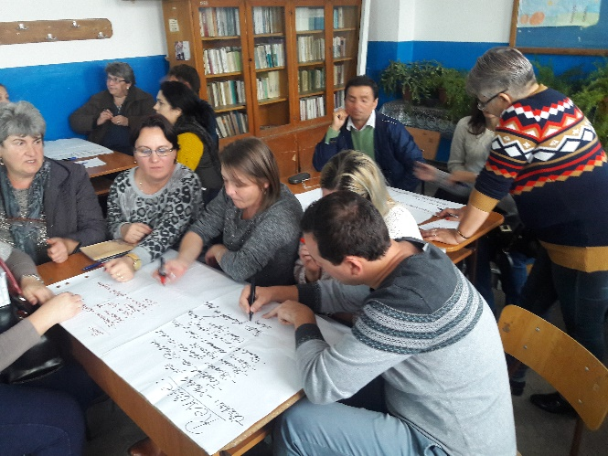 | 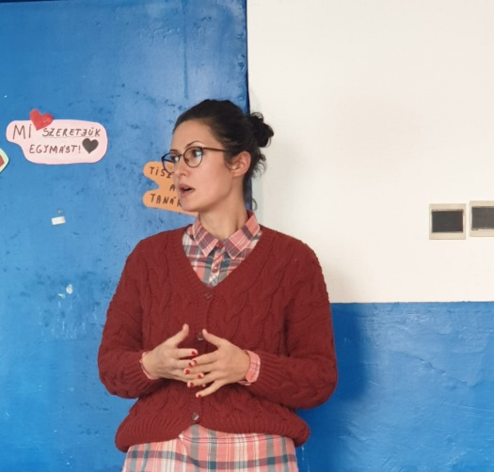

Duration
The project timeframe is 03.12.2018–02.06.2021. The project is funded by EU Erasmus+ Strategic partnership for adult education.

PARTNERS
- University of Helsinki Ruralia Institute (coordinator), Finland (link catre https://www.helsinki.fi/en/ruralia-institute)
- The Bucharest University of Economic Studies (ASE), Romania (link catre www.ase.ro)
- Estonian University of Life Sciences (EMU), Estonia (link catre https://www.emu.ee/en/home/)
- Nürtingen-Geislingen University (NGU), Germany (link catre https://www.hfwu.de/en/)
- InspirAlba, Scotland (link catre http://www.inspiralba.org.uk/)

RESULTS
The project outcomes include:
a) Open access learning material (link to https://www.ruralsehub.net/visenet-overview/)
The learning material is created in cooperation between strategic partnership of consortium based on the common consistency of good practices and experiences; and is divided to three thematic learning modules based on the practical needs of rural actors aiming to support the development of the rural social enterprises.
The learning modules are:
1) Community Activation and Participation Methods in Rural Areas (link to https://www.ruralsehub.net/community-involvement/)
2) Partnerships and Networking of Social Entrepreneurs (link to https://www.ruralsehub.net/networks-and-partnership/)
3) Social Enterprise Solutions for Sustaining Rural Communities and Measuring Social Impact. (link to https://www.ruralsehub.net/social-enterprise-solutions/)
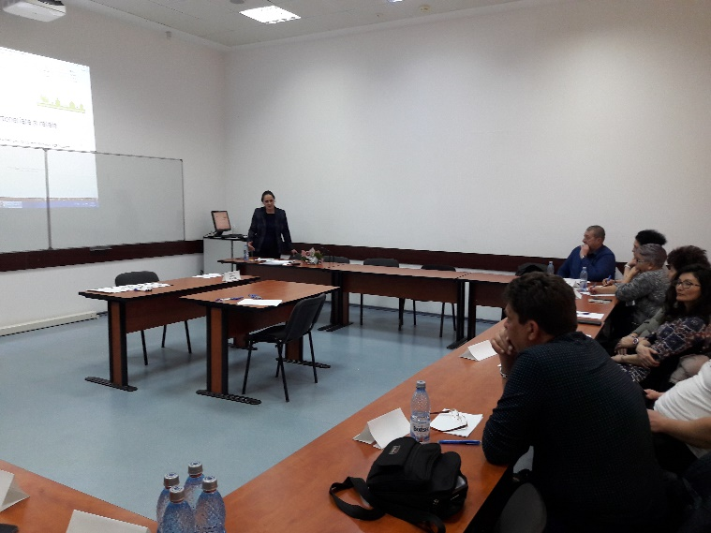 | 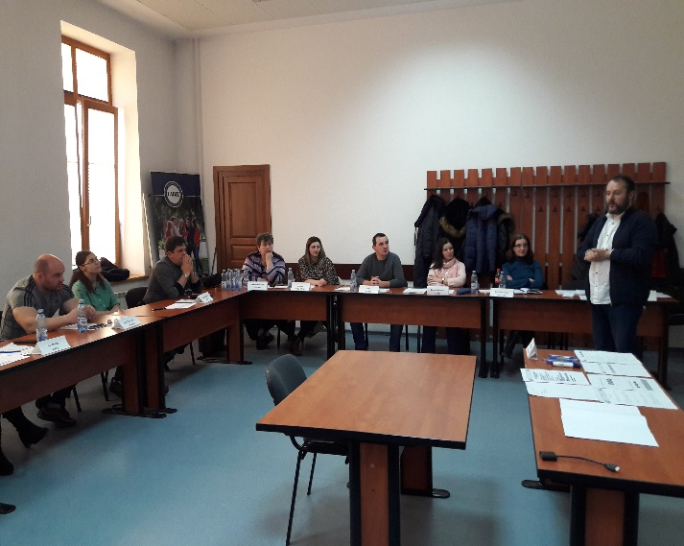

Each module is based on good practices and experiences identified by consortium and will be tested in national pilot groups.
In Romania, the pilot group included representatives of the rural community of Bahnea commune, the county of Mures. The feedback from piloting of the learning material can be read here (link to https://www.ruralsehub.net/feedback_and_piloting/).

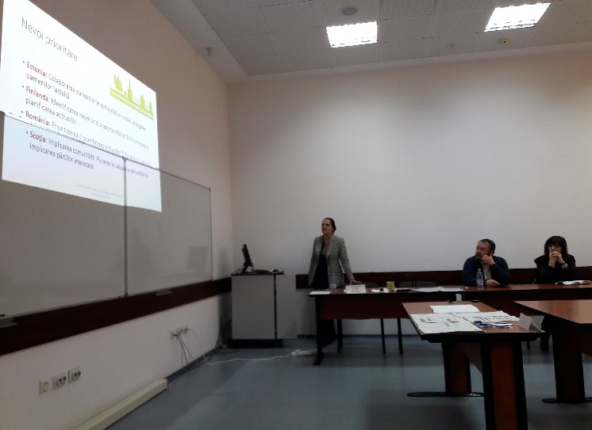 | 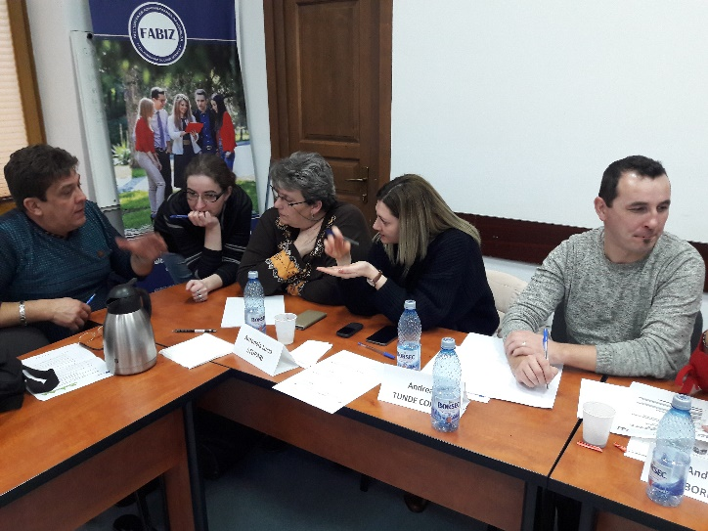

b) International Network of Rural Social Enterprises
In addition to support the future work of rural social entrepreneurs the project will establish an international network (Rural Social Enterprises) to give the members peer support, advice and a platform to exchange information and good practices to keep the process ongoing. The membership will be open to everyone interested in the topic.
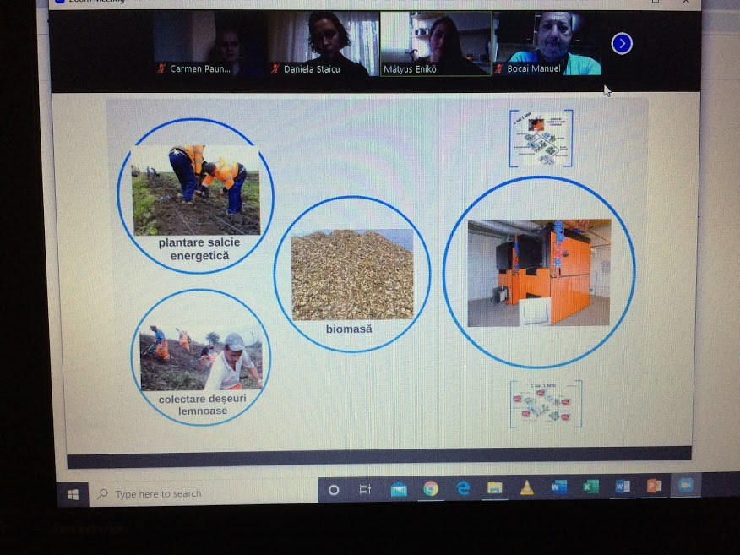 | 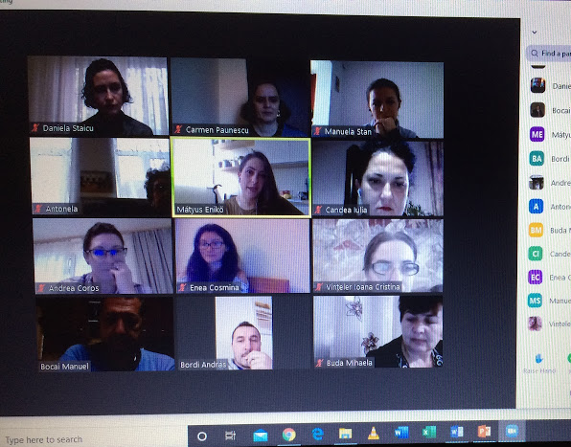

c) Practical Guidebook of Good Practices for supporting the development of social entrepreneurship (SE) in rural areas
The experiences gained through the project will be written into an e-guidebook of good practices for further use targeted at both learners and educators as well as policy makers.

CONTACT
Project manager (Romanian partner):
Prof. Dr. Carmen Paunescu, E-mail: carmen.paunescu@ase.ro

Team members (Romanian partner):
Dr. Daniela Staicu
Prof. Dr. Monica Dudian (short term expert)
Prof. Dr. Adriana Miclea (short term expert)

Contact details:
ASE, Romania: Carmen Paunescu, E-mail: carmen.paunescu@ase.ro
University of Helsinki, Finland: Katja Rinne-Koski, E-mail: katja.rinne-koski@helsinki.fi
EMU, Estonia: Roger Evans, E-mail: evanter.ou@gmail.com and Lea Sudakova, E-mail: lea.sudakova@emu.ee
NGU, Germany: Roman Lenz, E-mail: roman.lenz@hfwu.de
InspirAlba, Scotland: Ailsa Clark, E-mail: aclark@inspiralba.org.uk
Remark: The European Commission accepts no responsibility for the contents of this website.

